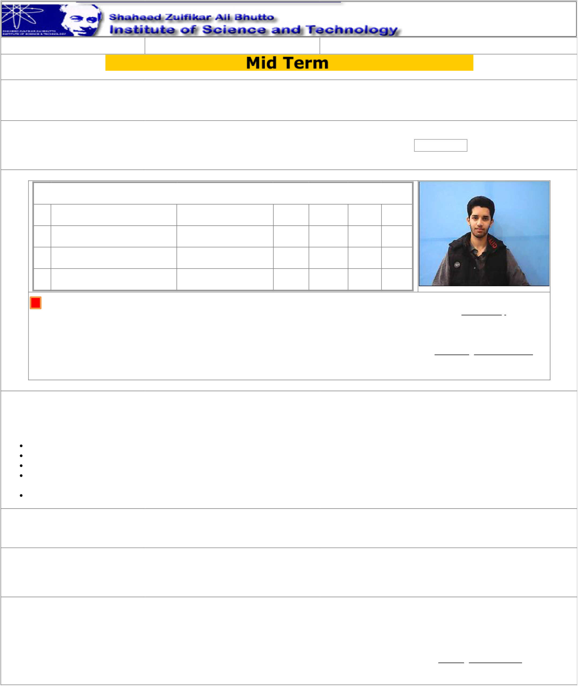

|  |  |  |
| --- | --- | --- |
| 11/5/24, 12:16 PM | **ADMIT CARD** | SZABIST Admit Card Fall2024 |
| Date: 11/5/2024 12:16:15 PM | **Islamabad Campus** |

Fall 2024

**ZabDesk Status: Active**

**Registration No: 2080243**   
**Student: Ammad Ud Din s/o Muhammad Azam**  **4 Courses Section: BSSE 8 A**

|  |  |  |  |  |  |  |  |  |
| --- | --- | --- | --- | --- | --- | --- | --- | --- |
| **No. Course** | | **Faculty** | **Section** | **T.** | **Present Absent** | | | Verified by  Sign & Seal  Academic Support Office |
| **Marked** |
| 1 | CSC 4205 Final Year Project-II | Babar Jehangir | BSSE 8 | 0 | 0 | 0 | |
| A |
| 2 | SEC 3307 Foreign Languages | Sidra . Tanvir | BSSE 8 | 11 | 8 | 3 | |
| A |
| 3 | SEC 4518 Visual Programming | Sajid Ali | BSSE 8 | 13 | 12 | | 1 |
| A |
| 4 | SEC 4532 Introduction to Cloud | Syed Muhammad Aqleem | BSSE 8 | 13 | 10 | | 3 |
| Computing | Abbas | A |
| Short attendance student is not allowed for Exam  Please check in the admit card for your name, registration number Class/Section and  courses.  Incase of any discrepancy communicate to the ASO immediately for necessary action. | | | | | | | |

Important Instructions for Students during Exams

**No candidate Without ADMIT CARD shall be allowed to sit in the examinations**   
Candidate shall be present in the examination hall 10 minutes before the commencement of the examinations.

No candidate in any case will be allowed to enter the examination hall after 30 minutes of the commencement of the exam **Students are not allowed to bring Mobile Phone or any other electronic device/Books/Notes inside the Examination Hall**   
**Use of any unfair means will Result in "F" grade for the entire course.**

**I hereby declare that I have read and understood all the rules and regulations of the Examinations, will strictly abide by the rules and regulations otherwise my Exam can be cancelled or any other action by authorities of the institute will be acceptable to me.**

_______________________________   
Student Signature

Approved by

Sign & Seal   
Examination Office

https://fallzabdesk.szabist-isb.edu.pk/AdmitCard/Default.aspx 1/1